Fuel Pump and Fuel Tank 234-1
234 Fuel Pump and Fuel Tank
General........................... | . . . 234-1 | To test turbo over-pressure switch ..... | .... 234-8
Roller-type Fuel Pump Assembly |  | Replacing Roller-type Pump .......... | .... 234-8
with Supply Pump ................. | . . . 234-2 | To replace roller-type pump assembly | .... 234-8
Rotor-type Fuel Pump Assembly ....... | . . . 234-2 | Replacing Rotor-type Pump........... | . . .234-11
Safety Precautions .................. | . . . 234-2 | To replace rotor-type pump assembly . . | . ..234-11
 |  | To replace fuel pump screen
Fuel Pump Troubleshooting ...... | . . . 234-3 | (models with rotor-type pump only) . . . | . . .234-13
Basic Troubleshooting Principles ....... | . . . 234-3 | Replacing Fuel Pump Check Valve . . . . . | 234-13
Fuel Pump Noise ................... | . . . 234-4
Operating Fuel Pump for Tests......... | . . . 234-4 | Fuel Tank and Lines.............. | 234-14
Supply Pump Quick Check |  | Fuel Tank......................... | . . .234-14
(roller-type pump only).............. | . . . 234-5 | To remove and install fuel tank ........ | . . .234-14
To test roller-type supply pump ........ | . . . 234-5 | To remove and install
 |  | fuel gauge sender unit ............ | . . .234-15
Fuel Pump........................ | . . . 234-5 | To replace fuel tank rollover valve ..... | . . .234-15
Fuel Pump Delivery Rate ............. | . . . 234-5 | Fuel Lines ........................ | . . .234-16
To test pump delivery ................ | . . . 234-5 | To replace fuel lines inside car ........ | . . .234-16
Fuel Pump Electrical Tests............. | . . . 234-6 | To replace banjo fitting on fuel line ..... | . . .234-16
Testing Fuel Pump Circuit ............ | . . . 234-6
To test fuel pump relay control circuit. . . . , | . . . 234-7 | TABLES
Checking for Voltage at the Fuel Pump | . . . 234-7 | a. Fuel Pump Applications ............. | .... 234-2
Testing Turbo Over-pressure Switch
(1985-1988 models only). ............ | . . . 234-8

GENERAL
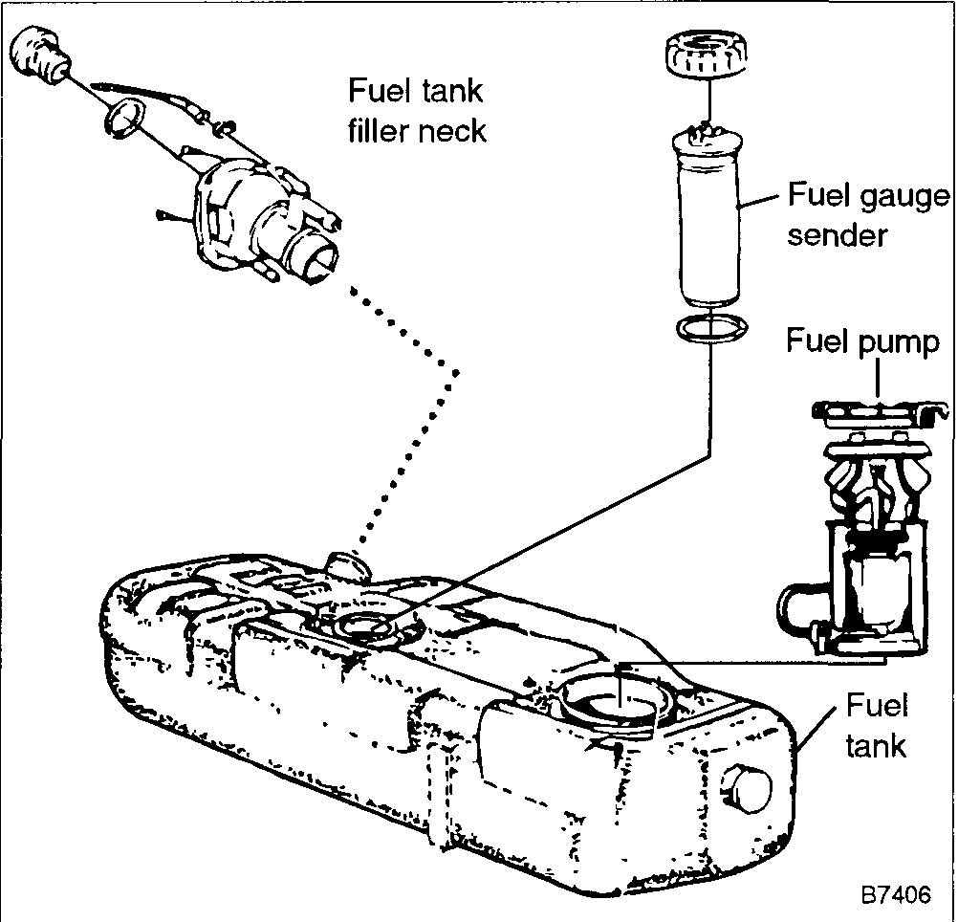
The injection-molded plastic fuel tank is located beneath the car, behind the rear seat. The fuel gauge sender and the electric fuel pump are mounted in the top of the tank. See Fig. 1. The fuel tank is designed to prevent overfilling and allow for fuel expansion. The filler cap contains a valve to prevent a vacuum from occurring in the tank. To prevent a backflow of fuel from the tank when the car is stopped, there is a check valve in the fuel return line from the fuel injection system.
The fuel pump is an electric rotary pump mounted inside the fuel tank. The fuel pump constantly circulates fuel throughout the system. Fuel is drawn from the tank, filtered, routed to the fuel injectors, regulated to maintain a constant pressure, and then recirculated back into the fuel tank.
NOTE
Fuel filter replacement is covered in 1 LUBRICATION AND MAINTENANCE.

Fuel flows through the pump and over the pump's electric motor. This helps cool the pump during normal operation. An inlet strainer helps prevent pump clogging. The main pump is
Fig. 1. Fuel tank and related components

234-2 Fuel Pump and Fuel Tank

mounted in areservoirto help prevent fuel starvation The fuel pump contains a bypass valve to prevent high pressure from damaging the system if there is a kinked or blocked fuel line Also, there is a check valve at the pump outlet to hold pressure in the system after the pump is turned off
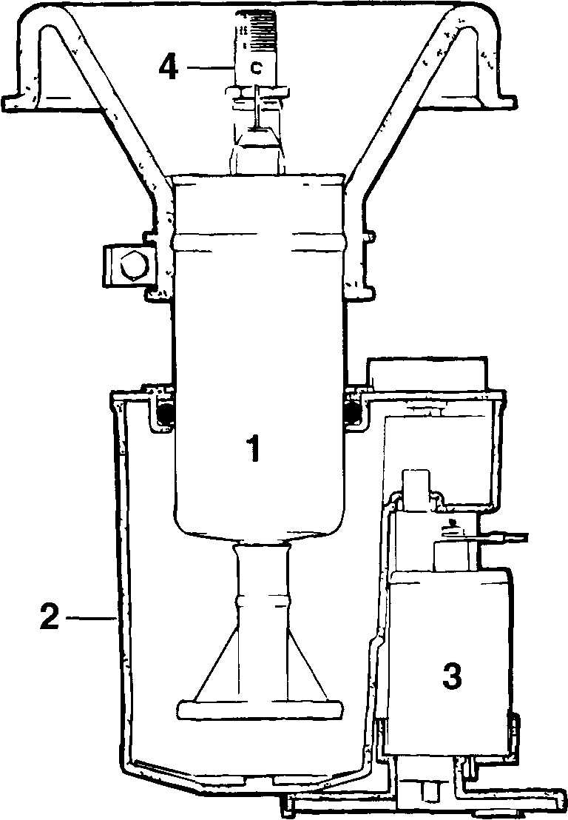
The electrical current that operates the fuel pump is controlled by a relay This ensures that the pump will not flood the engine, or continue running in the event of an accident or if the engine stalls Turbo models have an additional pump safety feature that turns the pump off during overboost situations
Two different fuel pump combinations and mountings are installed on Saab 900 models depending on the model year See Table a. The two pump types are not interchangeable, owing to a different fuel tank design
Table a. Fuel Pump Applications
Model | Pump type
1986-1988 Non-turbo* | Roller
1985-1989 Turbo models*
1989- and later Non-turbo | Rotor
1990 and later, Turbo

"Some early models may be equipped with a special replacement rotor type fuel pump This dealer installed service pump was designed to eliminate a complaint of poor dnveabllity or noisy pump operation and can be identified by its rubber mounting collar—other rotor type pumps are mounted with a threaded plastic collar
1 Fuel pump 3 Supply pump
2 Reservoir (pressure vessel) 4 Pump outlet check valve

Roller-type Fuel Pump Assembly with Supply Pump
Fig. 2. Roller type fuel pump assembly
Safety Precautions
Please read the following warnings before doing any work the fuel pump, fuel tank orfuel lines
Fig 2 shows the roller-type fuel pump assembly The pump is mounted in a fuel reservoir that is fed with fuel by the electric supply pump In addition, the fuel return from the fuel injection system also feeds the fuel reservoir This design helps prevent fuel starvation during hard cornering The reservoir has a safety valve that opens at 0 1 bar (1 4 psi) The pump is mounted to the tank by a rubber collar
NOTE
It may require at least two gallons of fuel to pnme the pump if the car ran out of gas If the car is not on level ground, additional fuel may need to be added
Rotor-type Fuel Pump Assembly
Fig 3 shows the rotor-type "ejector-style" fuel pump The rotor-type pump is similar to the roller-type pump, although the separate supply pump is not used The ejector picks up additional fuel from the bottom of the tank and forces rt into the reservoir
WARNING
• Always disconnect the negative (-) battery terminal and cov er the terminal with an insulated material whenever working on any fuel related component
• Gasoline is dangerous to your health Wear hand and skin protection when working on the fuel system Do not breathe fuel vapors and always work in a well-ventilated area
• Fuel and fuel vapors will be present dunng many of the operations descnbed in this repair group Do not smoke or create sparks Have an approved fire extinguisher handy
• The fuel injection system is designed to maintain pressure in the system after the engine is turned off Fuel will be expelled under pressure as fuel lines are disconnected This can be a fire hazard, especially if the engine is wann Always wrap a clean shop rag around the fitting before loosening or disconnecting any fuel line

Fuel Pump and Fuel Tank 234-3

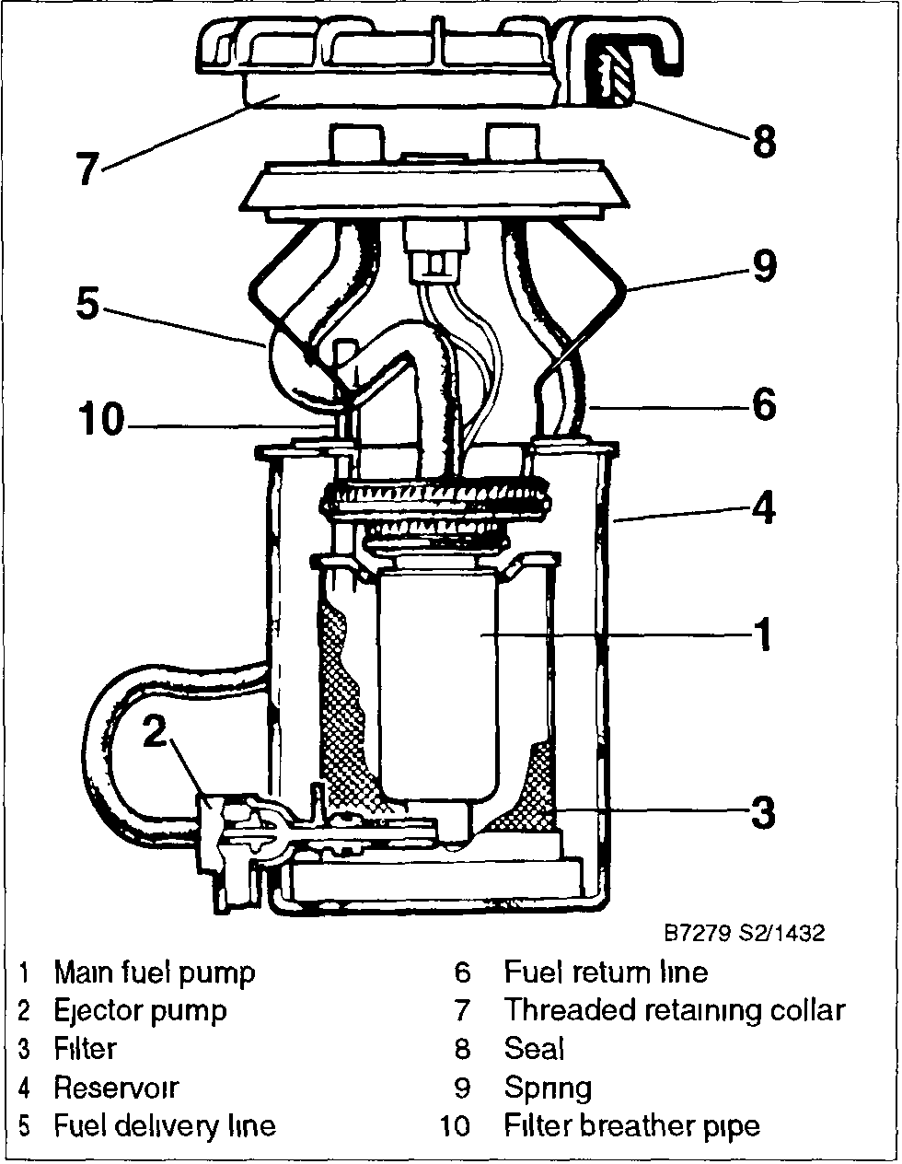
Fig 3. Rotor type fuel pump assembly
FUEL PUMP TROUBLESHOOTING
The fuel supply system is an integral part of the operation of the fuel injection system Problems such as a no-start condition, hesitation or stalling may be due to poor fuel delivery There are some preliminary tests to quickly determine if the fuel pump or its electrical circuit are causing the problem Some of the tests described below require special test equipment, such as a fuel pressure gauge
CAUTION
• Avoid the use of compressed air nearby, and do not move the car while the fuel system is open
• When replacing parts, install only new, clean components Seals and 0-nngs should always be replaced rather than reused
NOTE
To help prevent poor fuel delivery due to pump cavitation, Saab recommends avoiding the use of alcohol-enhanced fuel above ambient temperatures of 75°F (24°C)
Basic Troubleshooting Principles
The basic function of the fuel pump is to deliver an adequate amount pressurized fuel Problems caused by a fault with fuel pump range from a no-start condition to intermittent poor performance and dnveability These problems can be the result of a fault in the pump electrical circuit or a worn or faulty pump
Begin troubleshooting with a simple check of the fuel pump electrical circuit The pump should run while cranking the engine with the starter If necessary, remove the access cover under the trunk floor and listen or feel to see whether the pump is running If the pump does not run, see Fuel Pump Electrical Tests below
If fuel delivery problems are suspected, begin troubleshooting with a check of the fuel pump delivery rate See Fuel Pump Delivery Rate The test will indicate whether further tests are necessary This is especially important on high-mileage cars, where normal pump wear may decrease delivery volume
Also check for correct pump installation, a clogged pump strainer, or a bad supply/ejector pump Any combination of these may cause the problems listed above

NOTE
Cleanliness is essential when working with the fuel system Even a tiny particle of dirt can cause trouble if it reaches an injector
General engine management and dnveability troubleshooting should begin by consulting 200 Engine—General.
CAUTION
• Thoroughly clean fuel line unions before loosening or disconnecting them Use only clean tools
• Keep removed components clean, and seal or cover them with a clean lint-free cloth, especially if the repair cannot be finished immediately
NOTE
• On Turbo models, a faulty over-pressure switch may cause momentary fuel pump cut-out or a no-start condition See Testing Turbo Over-pressure Switch (1985-1988 models only) for more information
• On models with rotor-type pumps poor performance may be caused by a ruptured or ballooned delivery hose in the pump assembly This hose is available as a replacement part See Replacing Rotor-type Pump for additional information
• Poor dnveability or performance on 1988 and some 1989 models with roller-type or rotor-type pumps may be due to a blocked return line check valve at the fuel tank causing excessive line pressure The problem is covered under Saab's vehicle warranty For more information see an authorized Saab dealer

234-4 Fuel Pump and Fuel Tank

NOTE
During 1990 model production, a modified rotor-type pump was installed as a running change. The new design helps eliminate pump cavitation, pump noise, and pump overheating. The new pump can be retrofitted to earlier models with the rotor-type (threaded collar) pump
Fuel Pump Noise
Fuel pump noise does not always indicate a bad pump. The amount of noise that is transmitted to the passenger compartment varies with the car. Humming or buzzing at various levels is generally considered normal, while clicking, ratcheting or grinding may signal imminent pump failure.
On roller-type pumps, improper pump or fuel tank installation can increase pump noise, as can a faulty supply pump. On rotor-type pumps, a clogged ejector pump can often cause noise. Many times the main fuel pump is replaced needlessly when the supply or ejector pump is at fault.
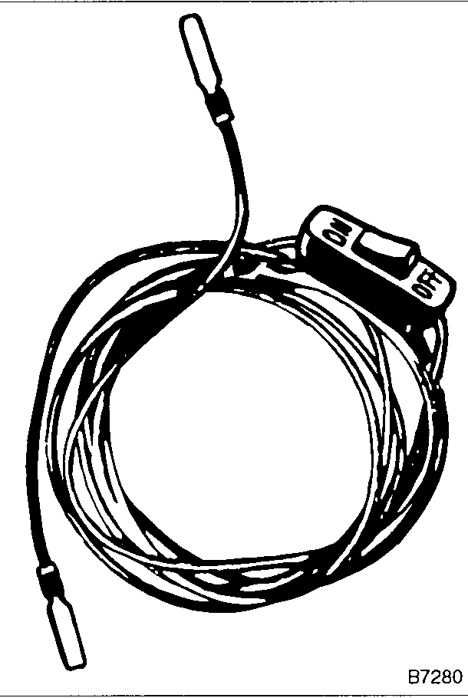
Fig. 4. Jumper wire with flat-blade connectors and switch for running fuel pump without running engine

NOTE
Supply pump test procedures are covered below under Supply Pump Quick Check (roller-type pump only)
To run the pump, remove fuses number 27 and 30. With the ignition off, connect the jumper wire and switch as shown in Fig. 5. Turn the switch ON to run the pump.

Operating Fuel Pump for Tests
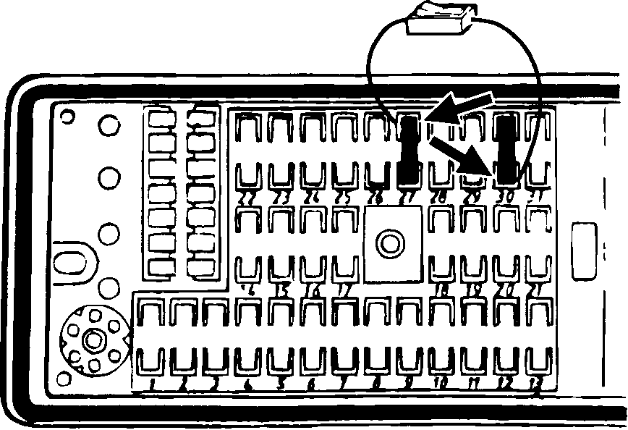
The electric fuel pump only runs when the cars is running or being started. This is to prevent running the fuel pump indefinitely if the engine stalls. Testing the fuel pump and the fuel injection system requires running the pump with the engine off.
The procedure for operating the pump uses a temporary wiring connection on the fuse/relay panel to bypass the fuel pump relay. The preferred method is to use a remote switch, such as the Saab special tool, Part No. 83 93 886, but you can accomplish the same thing with a homemade jumper wire and an in-line switch. See Fig. 4.

CAUTION
• A homemade jumper wire with a switch should be at least 1 5 mm metnc wire size (14 gauge-AWG) and, for safety, should include a 20 amp in-line fuse.
• Avoid damaging the fuse sockets. The ends of the jumper wire should be flat-blade connectors that are the same size as the sockets in the fuse panel.
• Connect and disconnect the remote switch or jumper wire only with the switch in the off position
Fig. 5. Schematic view of jumper wire and switch connected at fuse sockets (fuses removed) for running fuel pump Fuse/relay panel is in engine compartment on top of left fender
NOTE
If the pump runs only when the jumper is connected, the relay or winng is faulty If the pump doesn't run with the jumper installed, the problem is in the wiring to the pump or the pump itself. See Fuel Pump Electrical Tests for more information

Fuel Pump and Fuel Tank 234-5

Supply Pump Quick Check
(roller-type pump only)
The following test will help determine whether a faulty supply pump is the cause of fuel delivery problems. A faulty supply pump usually manifests itself through a noisy fuel pump.
NOTE
If fuel comes out of the relief valve, the supply pump is working correctly If no fuel comes out, the supply pump is most likely faulty and should be replaced The supply pump is available as a replacement part See Replacing Roller-type Pump below.

WARNING
• The fuel tank must be no more than 3/4 full when making this check or fuel may be spilled
• Fuel will be expelled Do not disconnect wires that could cause sparks Have a fire extinguisher handy Perform the test outside if possible Have a supply of rags handy to clean up any spills
To test roller-type supply pump
1. Working in the trunk, remove the pump access cover. Disconnect the main pump terminals and slacken and remove the mounting boot clamp. See Fig 6.
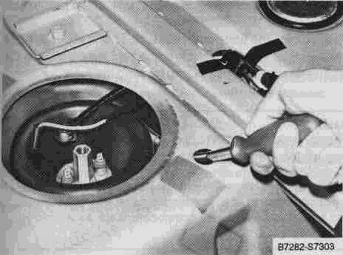
Fig. 6. Fuel pump mounting boot clamp being loosened using flexible socket driver
2. Carefully peel back the pump mounting boot so that the top of the fuel pump reservoir is visible.
3 Run the fuel pump as described above under Operating Fuel Pump for Tests As the supply pump runs, fuel should be forced out of the reservoir relief valve. See Fig. 7.
WARNING
The fuel forced out of the relief valve will be partially vaponzed and is extremely flammable Do not smoke or create sparks Have an approved fire extinguisher handy
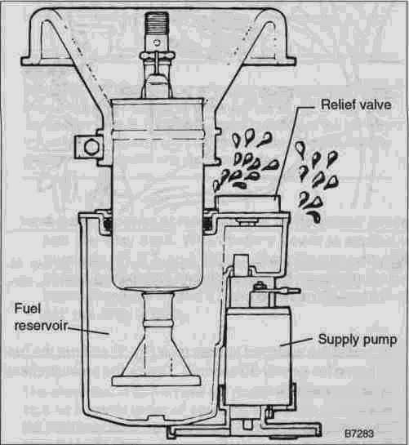
Fig. 7. Cutaway view of roller-type fuel pump showing fuel forced out of relief valve as supply pump operates
4. When finished, clean up all spilled fuel and reinstall the pump mounting boot.
FUEL PUMP
Fuel Pump Delivery Rate
This test checks the fuel pump output. Insufficient fuel delivery can result in poor performance, hard starts, hesitation, and stalling
To test pump delivery
1 Working in the engine compartment, disconnect the fuel return line from the pressure regulator. See Fig. 8. Attach a length of fuel line to the pressure regulator and place the hose into a 2 liter (2 quart) container.

234-6 Fuel Pump and Fuel Tank

WARNING
Fuel will be expelled as the line is disconnected
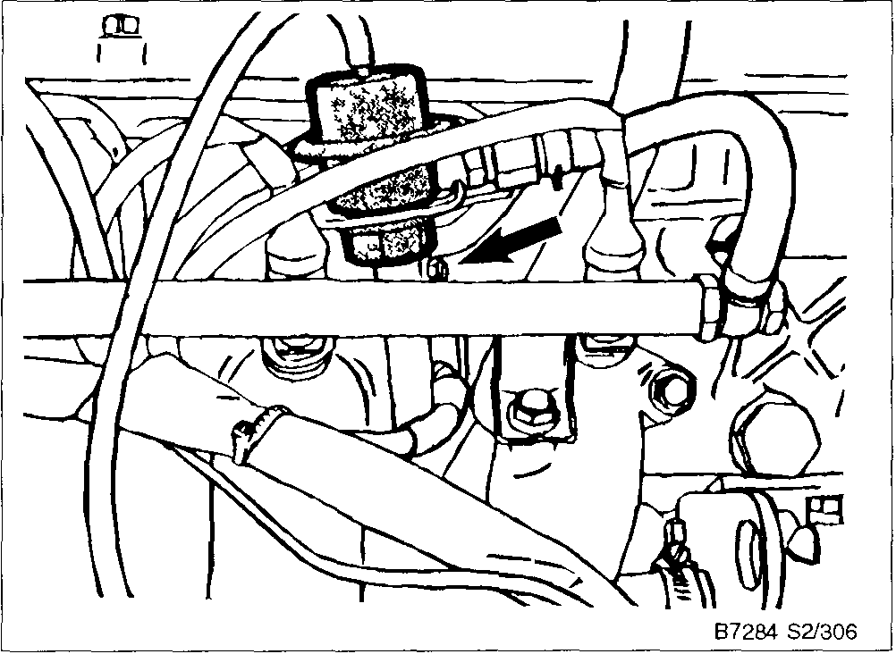
Pig. 8. Disconnect fuel return line at pressure regulator (arrow) Attach length of hose to regulator and place hose end into con tamer
2 Install the switched jumper (see Fig 5) and run the fuel pump for exactly 30 seconds Checkthe amount of fuel in the container.
Fuel Pump Delivery Volume
• minimum of 900 ml (30 oz.) in 30 seconds
Causes of insufficient delivery:
• system pressure incorrect. Check fuel pressure as described in 240 Fuel Injection
• clogged pump strainer/fuel filter/supply line
• voltage at fuel pump incorrect. See Fuel Pump Electrical Tests
• worn fuel pump
If fuel delivery volume is low, reconnect the fuel return line to the pressure regulator. Install a pressure gauge as described in 240 Fuel Injection Run the fuel pump and slowly clamp shut the fuel return line at the pressure regulator. Immediately release the pinched hose as soon as the pressure approaches 6 bar (83 psi). When the return line is clamped shut, the gauge needle should rapidly rise to about 6 bar (83 psi). If not then the pump is probably faulty.
CAUTION
Allow the fuel pressure to nse slowly Do not allow the pressure to exceed 6 bar (83 psi) Damage to the fuel pump or lines can result
Fuel Pump Electrical Tests
The fuel pump electrical circuit is relay controlled, which means that power to the pump must pass through the relay before the pump can run. The LH control unit controls the re-lay.To keep the relay closed and the pump running, the LH control unit must get a signal that the engine is turning over This pulse signal comes from the ignition system. 1985 through 1988 Turbo models use an additional over-pressure switch to prevent engine damage as a result of turbocharger wastegate malfunction The over-pressure switch cuts off power to the fuel pump relay whenever boost pressure is above a safe level.
NOTE
• Testing of the turbo over-pressure switch is covered below
• An additional engine over-rev protection feature turns off the fuel injectors if the engine speed goes above 6,000 rpm This feature is handled by the LH control unit
If the pump fails to run at all when the starter is cranked, the problem can be due to one of the following' the fuel pump relay, the electrical circuit, the LH control unit, or the pump itself
Always checkthe fuel pump fuse first. This is especially true in cold weather when moisture in the fuel may freeze in the pump, overloading the circuit and blowing the fuse.
CAUTION
• Do not bypass a failed fuse to power the circuit directly until finding out why the fuse has failed
• Repeated fuse failures indicate an electncal problem, usually a short to ground or an overloaded circuit A circuit overload can be caused by a faulty component, such as a jammed pump
NOTE
For the best troubleshooting results, perform all tests listed below in the sequence in which they appear
Testing Fuel Pump Circuit
Check the circuit that powers the pump by bypassing the relay to run the pump. Remove the fuel pump relay, shown in Fig 9. Install a jumper wire between sockets 30 and 87b in the relay panel. The pump should run
If the pump runs with the relay bypassed, you can assume that the pump and the wiring to the pump is OK. It is either the relay, or the circuit that controls the relay that is faulty See Testing Relay Circuit below.

Fuel Pump and Fuel Tank 234-7

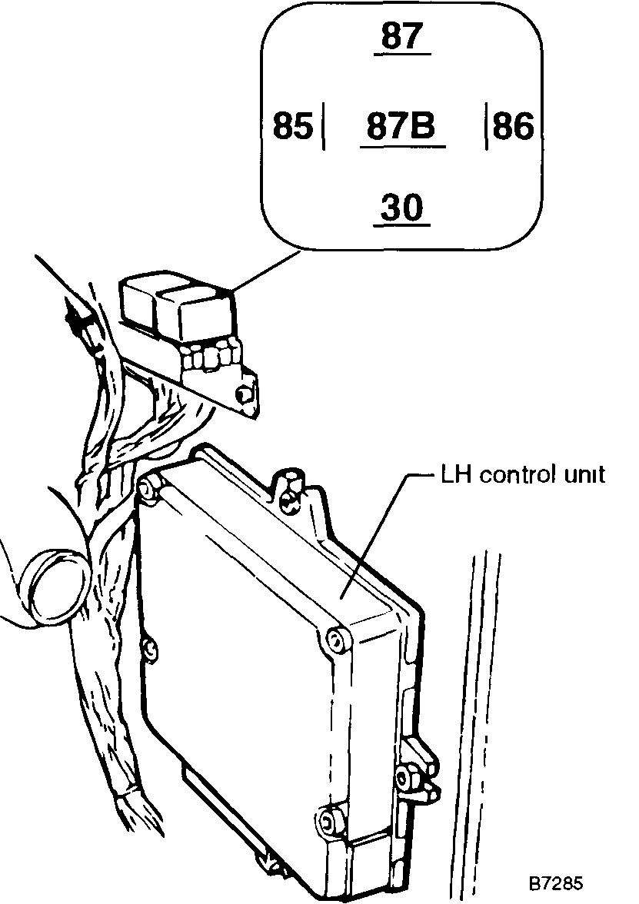
Fig. 9. Fuel pump relay and LH control unit located behind right side trim panel in front passenger footwell Inset shows relay ter minal designations on relay panel with relay removed
If the pump does not run with the relay bypassed, then there is a fault in the fuel pump circuit Power may not be getting from the relay panel to the pump, or even from the battery to the relay panel Use the wiring diagrams in 371 Wiring Diagrams, Fuses and Relays to check power and ground in the circuit
To test fuel pump relay control circuit
1 Remove the fuel pump relay See Fig 9 above
2 Turn the ignition on and check for power at terminal 86 of the fuel pump relay socket If there is no power then either the fuel-injection main relay or the wiring from the main relay to socket 86 of the fuel pump relay panel is faulty
NOTE
See 240 Fuel Injection for information on checking the LH
main relay See 371 Wiring Diagrams, Fuses and Relays for
all LH wiring diagrams
3 Connect a voltmeter across relay socket terminals 86 (+) and 85 (-) Briefly crank the starter and check that there is battery voltage If not, the ground signal from the LH control unit to the fuel pump relay is not present
CAUTION
Use only a digital voltmeter with high input impedance when testing solid-state components
NOTE
The LH control unit must get an ignition pulse telling it that the engine is being cranked or running This signal comes from the ignition system If this signal is not present at the LH control unit, the fuel pump relay will not operate See 240 Fuel Injection for LH control unit electrical tests
4 If there is power at relay sockets as described above, test the relay itself When battery power is applied to terminals 85 (-) and 86 (+), the relay should click closed (pull-down) and there should be continuity between terminals 30 and 87 and between 30 and 87b If not, the relay is faulty
NOTE
The above test in step 4 does not guarantee that the relay is working correctly under all operating conditions Sometimes the relay may work intermittently only when it has been operating for some time
Checking for Voltage at the Fuel Pump
This test checks to see if the correct voltage is reaching the pump To make the test, remove the pump access cover in the floor of the luggage compartment With the engine off, run the fuel pump as described above under Operating Fuel Pump for Tests Then measure the voltage across the pump terminals See Fig 10
Voltage at fuel pump with pump running • at least 11 5 volts
If the voltage is below 11 5 volts, check all wiring connections in the circuit for looseness or corrosion Clean or tighten as necessary If there is no voltage at the pump, check the wire between the pump and the relay and the ground wire from the pump to the center crossmember in the trunk

234-8 Fuel Pump and Fuel Tank

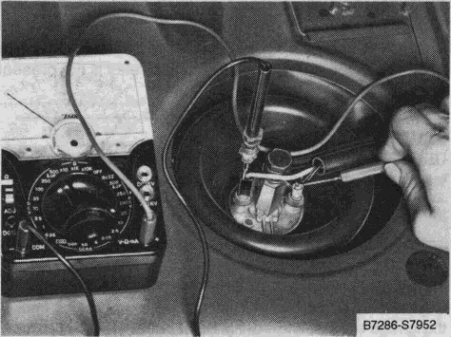
Fig. 10. Checking for voltage across fuel pump terminals with pump running and engine off. Roller-type pump shown. On models with rotor-type pump probe from back of wiring connector.
Testing Turbo Over-pressure Switch
(1985-1988 models only)
The over-pressure switch is mounted under the instrument panel to the left of the steering wheel, just behind the fuse/relay panel. Fig. 11 shows the switch. The switch is used as a backup safety device in the event the turbocharger wastegate malfunctions. If the turbocharger boost pressure exceeds a safe level, the over-pressure switch interrupts power to the fuel pump. The tests described below require the use of handheld vacuum/pressure pump.
NOTE
All 1989 and later Turbo models also have an over-pressure safety feature^ although it is handled by the 2.4 LH control unit instead of a separate pressure switch.
To test turbo over-pressure switch
1. Working beneath the left-hand side of the instrument panel, disconnect the vacuum hose from the switch and plug the hose. Attach the pump to the switch using the piece of hose.
2. With the engine running, slowly increase pressure. The engine should shut off when the pressure reaches approximately 1 bar (14.5 psi).
3. If the engine does not shut off, turn off the engine and disconnect the harness connectors from the switch. Connect an ohmmeter across switch terminals 1 and 2. With no pressure applied to the switch, there should be continuity. With 1 bar (14.5 psi) of pressure applied to the switch, there should be no continuity. If any faults are found, replace the switch.
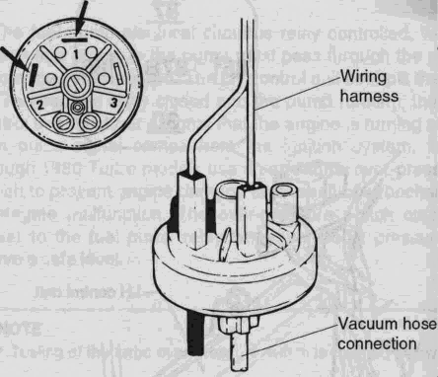
Fig. 11. Turbo over-pressure switch used on 1985-1988 Turbo models. Be sure to connect switch wires to terminals 1 and 2, as shown at arrows.
Replacing Roller-type Pump
When replacing a roller-type pump, pay close attention to the installed height and orientation of the pump. Incorrect installation can lead to fuel starvation or pump failure. Be sure to have new fuel line sealing washers on hand.
To replace roller-type pump assembly
1. Disconnect the battery negative (-) cable and cover the terminal pole on the battery. Remove the fuel pump access cover in floor of luggage compartment. Disconnect the pump wiring.
NOTE
On cars with LH 2.4 fuel injection, disconnecting the battery will erase the control unit's adaptive memory. When the engine is restarted it may operate erratically. The engine must be driven for at least 30 minutes for the adaptive memory to be reset.
2. Disconnect the fuel line from the pump. Using an open-ended wrench, hold the pump still while removing the dome nut. See Fig. 12.
WARNING
Fuel will be expelled when the fuel lines are disconnected and the pump is removed. Do not smoke or create sparks. Have an approved fire extinguisher handy.

Fuel Pump and Fuel Tank 234-9

CAUTION
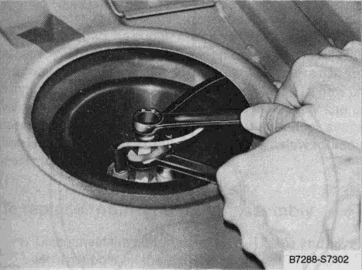
Fig. 12. Fuel line being removed from fuel pump.
3. Lift the pump up just enough to disconnect the fuel return line from the fuel reservoir and the wiring from the supply pump.
4. Using a flexible nut driver, loosen the collar mounting strap. See Fig. 13. Carefully lift out the pump.
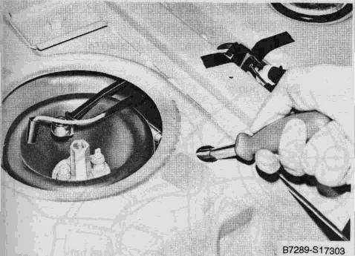
Be careful not to damage the fuel pump terminals when loosening the center banjo bolt. If a terminal is broken off it is not repairable and the entire pump must be replaced. A special wrench is available to reduce the possibility of breaking a pump terminal. The wrench is Saab Part No. 83 94 330
6. To assemble the pump, install the wiring to the supply pump and install the supply pump into the reservoir, pressing it against the stop.
NOTE
On the supply pump, the white wire goes to the positive (+) terminal and the black wire to the negative (-) terminal.
7. Install the main pump into the collar and adjust it to the height shown in Fig. 14. Install the pump with collar into the reservoir and adjust the total height of the pump assembly to the specification shown in the figure.
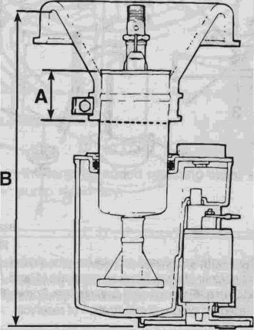

Main Fuel Pump
• Dimension A
All. ......................... 42+2 mm (1.65+.08 in.)
• Dimension B
1985-eariy 1988
(uptoVINJ3001527
and J7004073) ................... 225 mm (8 7/8 in.)
Early 1988 and later
(from VINJ3001528
and J7004074). ................... 242 mm (9 1/2 in.)

Fig. 13. Fuel pump mounting collar strap being loosened.
5. To disassemble the pump, pull the main pump out of the reservoir. The supply pump is held with a bracket and two screws.
Fig. 14. Assembled dimension of main fuel pump in reservoir and rubber collar.

234-10 Fuel Pump and Fuel Tank

NOTE
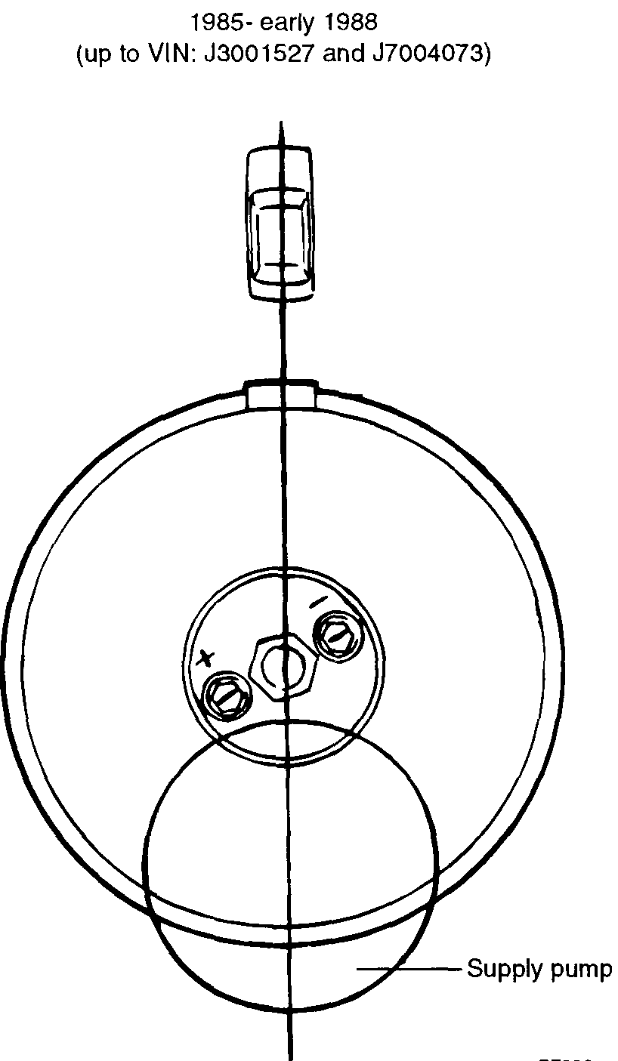
• Proper pump height and pump orientation in the tank is very important. Scribe a mark 42 mm (1 21/32 or 1.65 in.) from the top of the pump to accurately position the collar to the pump during assembly.
• See 1 LUBRICATION AND MAINTENANCE for information on VIN numbers and their locations.
• The supply pump on some early models may be equipped with a "bow-tie" style strainer. For better fuel pick-up and delivery, a modified strainer should be installed. See Fig. 15. The new strainer is Saab Part No. 93 86 491.
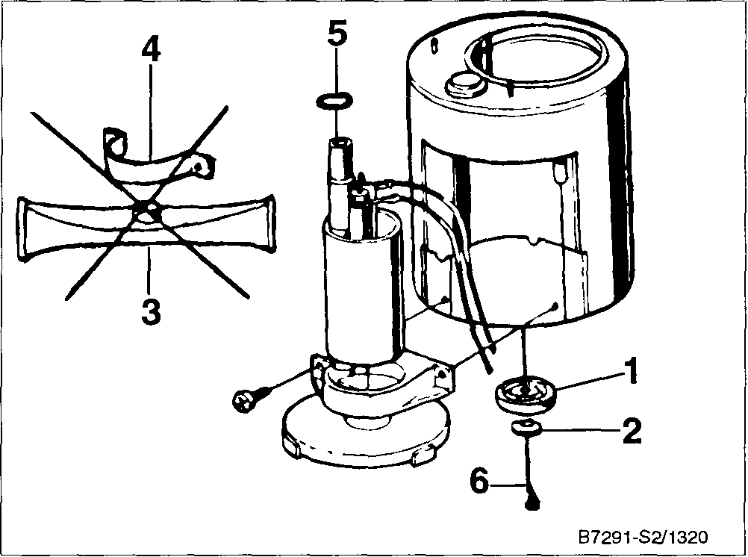

Fig. 15. Where installed, always replace bow-tie strainer (3) with modified strainer shown. Replace supports (1 and 2), clamp (4), and 0-ring (5) when using new strainer. Screw (6) must be reinstalled for proper pressunzation of reservoir.
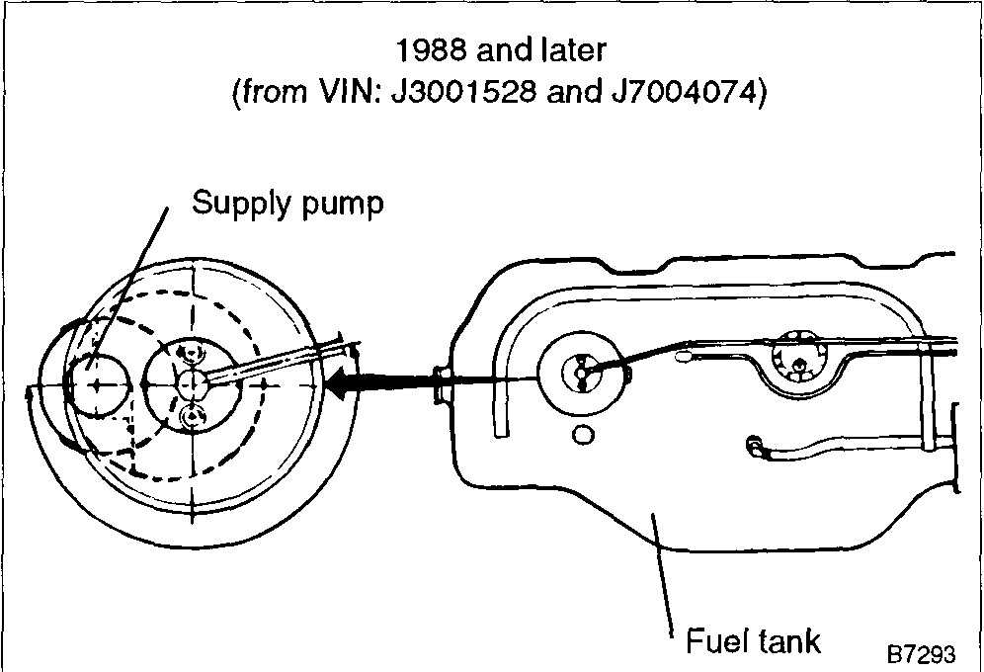
8. Install the pump into the tank, making sure to reconnect the supply pump connector and the fuel return line before fully installing the pump. Orient the pump as shown in Fig. 16 or Fig. 17. Tighten the mounting collar clamp.
9. Using new sealing washers, reinstall the fuel line and banjo bolt/dome nut. Reconnect the wiring.
NOTE
The direction of pump rotation is determined by the polarity of the wiring, so + and - signs are cast in the pump housing to ensure proper wiring connection.
Fig. 16. 1985 to early 1988 fuel pump orientation relative to car.

Fig. 17. Early 1988 and later fuel pump orientation relative to fuel tank,

Fuel Pump and Fuel Tank 234-11

Replacing Rotor-type Pump
When removing and installing the rotor-type fuel pump, always replace the 0-nngs that seal the fuel lines and the pump to the tank. This is especially important on 1990 and later models because the 0-nngs are designed to swell when exposed to fuel vapor. These 0-nngs cannot be reinstalled unless they are completely dry.
There were two styles of rotor-type pumps installed. The early version had the supply check valve installed in the pump assembly. The later pump (identified by the internal T-fitting in the pump's supply line) had the supply check valve fitted in the supply line fitting. If the early pump is replaced, a new check valve must be inserted into the end of the supply line using special tools, as the early-style pump is no longer available. See Replacing Fuel Pump Check Valve below for replacement procedures.
To replace rotor-type pump assembly
1. Disconnect the battery negative (-) cable andcoverthe terminal pole on the battery.
NOTE
On cars with LH 2 4 fuel injection, disconnecting the battery cable will erase the control unit's adaptive memory When the engine is restarted it may operate erratically for up to 30 minutes.
2. Working in the luggage compartment, remove the access panel from above the pump.
3. Remove the clamp that secures the fuel lines and wiring. See Fig. 18. Disconnect the wiring from the pump.
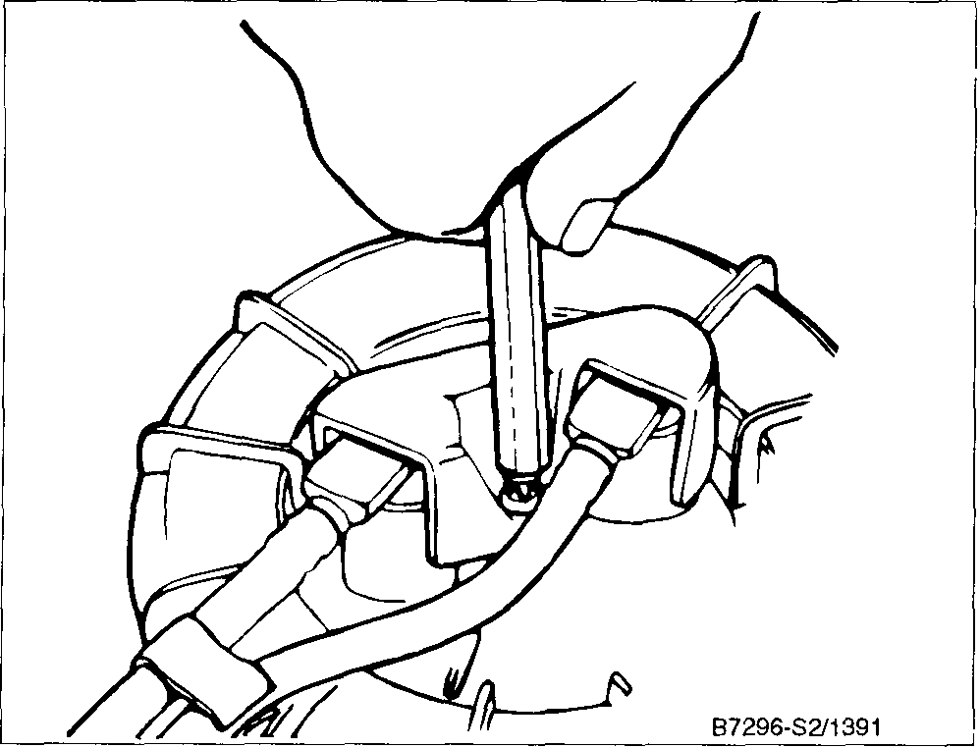
Fig. 18. Fuel line and pump wiring hold down clamp
4. Using a round-jawed pliers, disconnect the fuel lines by pulling them straight up See Fig 19. Tie the fuel lines back
WARNING
Fuel will be expelled under pressure. Wrap clean rags around the fuel line fittings before removing them from the pump
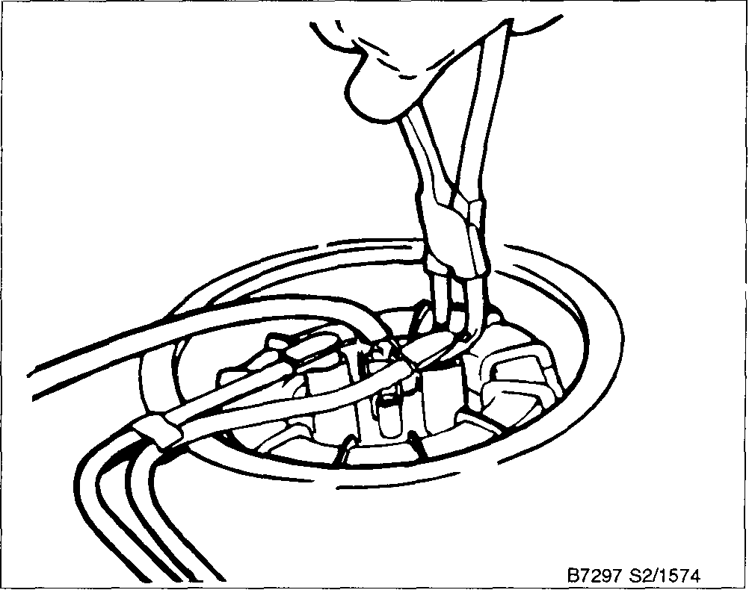
Fig. 19. Fuel lines being removed
5. Loosen the large threaded retaining collar while holding the pump stationary.
CAUTION
The pump must not turn when loosening the retaining collar or the ejector assembly could be damaged A special tool is available to hold the pump stationary as the collar is loosened See Fig. 20.
6. Lift the pump assembly up to allow excess fuel to drain, then tilt it slightly to remove it from the tank. Place it in a receptacle to catch any remaining fuel.
NOTE
Carefully inspect the fuel delivery line . If the hose is distorted or ballooned, it should be replaced This hose is available as a replacement part through and authonzed Saab dealer Be sure to check the fuel system pressure if the hose is distorted Excessive fuel pressure due to a blocked check valve will cause the new hose to balloon
7. Carefully insert the new pump assembly (ejector pump side first) into the tank so that the fuel line fittings on the pump are parallel with the length of the car and that the matching mark on the pump is aligned with the mark on the tank. See Fig. 21.

234-12 Fuel Pump and Fuel Tank

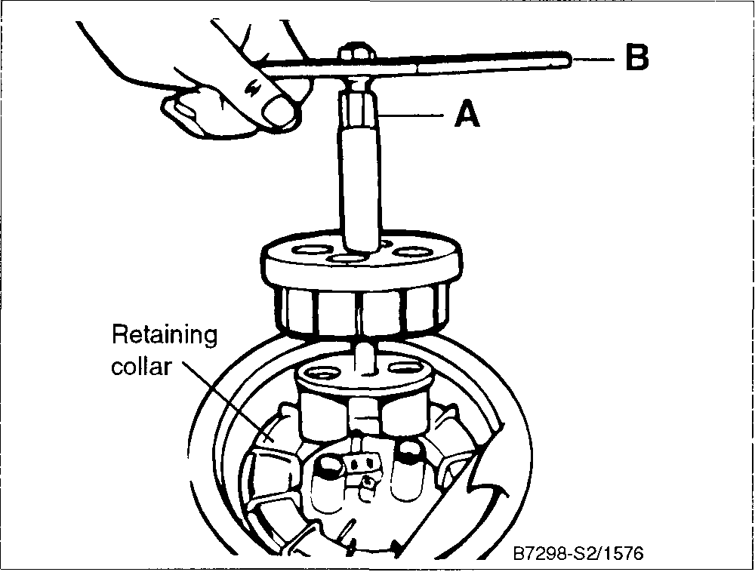
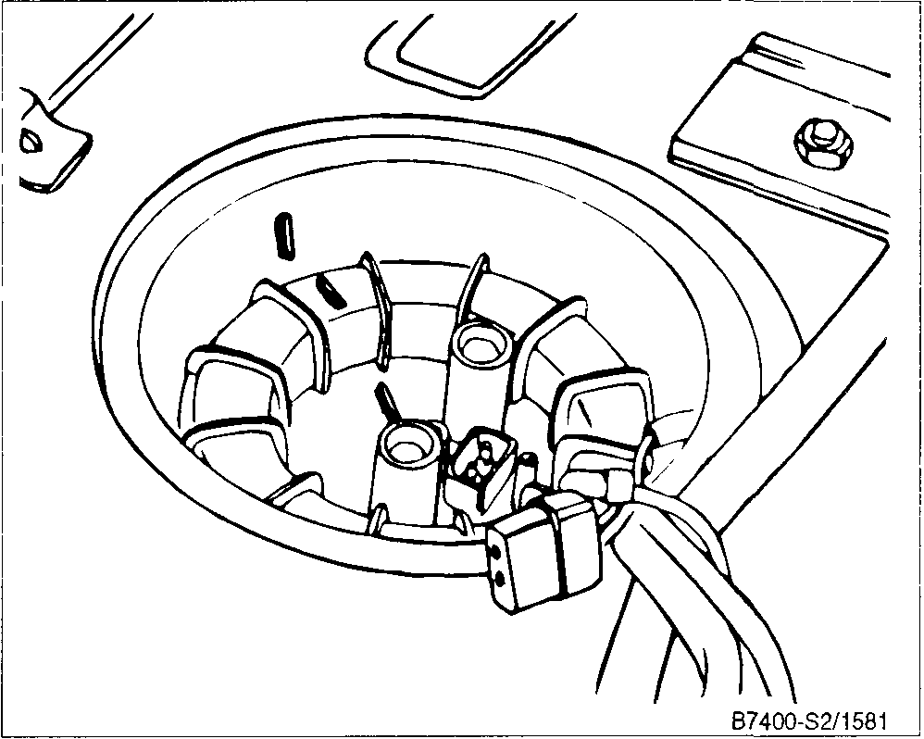
Fig. 20. Special tool for fuel pump removal. Loosen collar by turning outer part of tool with open-end wrench at A while holding pump stationary with handle (B) on inner tool.
NOTE
Make sure that the pump fits between the locating ribs in the bottom of the tank and that the matching marks on the pump and tank are exactly aligned.
CAUTION
Do not allow the pump assembly to turn when tightening the collar. Otherwise the ejector assembly may be damaged.
NOTE
The locating marks on the retaining collar must be within 30° to either side of the marks on pump and tank.

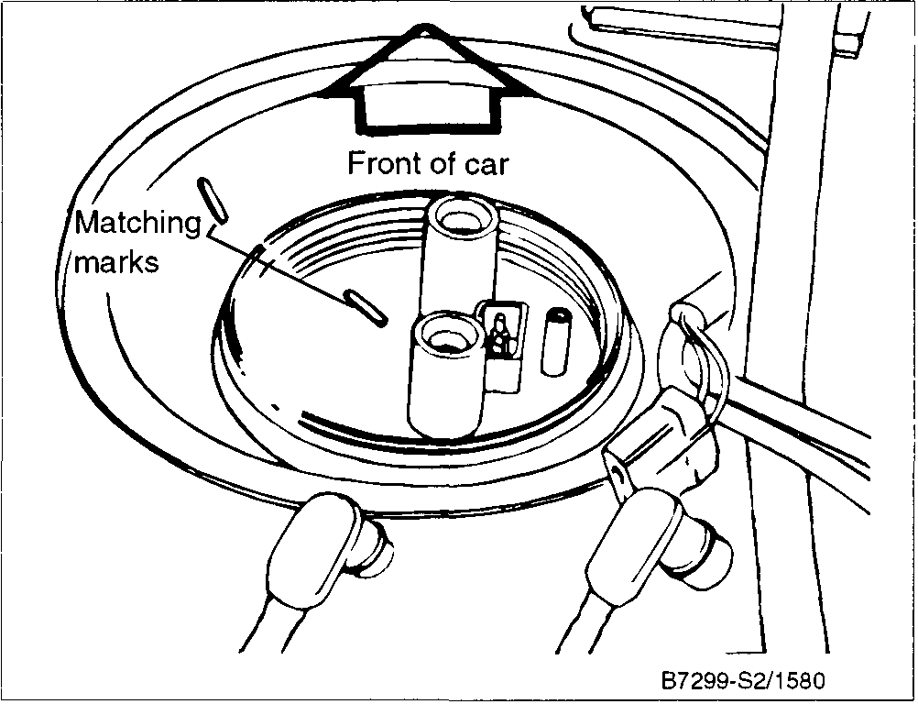
Fig. 22. Matching marks on retaining collar and fuel tank correctly aligned.
9. On 1990 and later models, fit the new collar seal in the groove in the fuel tank. Install the retaining collar, tightening it using Saab special tool no. 83 94 462 or an equivalent. See Fig. 23.
Tightening torque
• Fuel pump to fuel tank (threaded collar) 1990 and later................ 55 Nm (40 ft-lb)

8. On 1989 models, lubricate the new collar seal with petroleum jelly (Vaseline) and insert it into the retaining collar. Install the collar while aligning the matching marks. See Fig. 22. Press down firmly on the collar until it engages the tank. Tighten the collar until it stops.
Fig. 21. Correct alignment of pump assembly relative to tank.
CAUTION
Do not allow the pump assembly to turn when tightening the collar. Otherwise the ejector assembly may be damaged. Check that the locating marks on the pump and tank are still aligned after tighening.
10. Using new 0-rings, reconnect the fuel lines. The return line (with check-valve) attaches to the outlet nearest the front of the car. The supply line attaches to the rear outlet. Reconnect the wiring and fit the clamp.

Fuel Pump and Fuel Tank 234-13

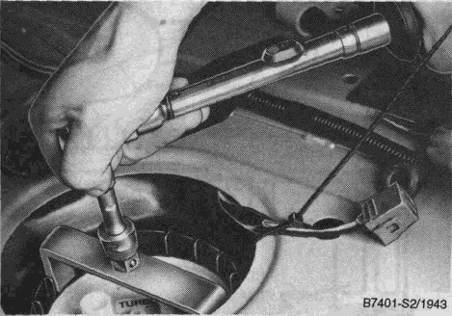
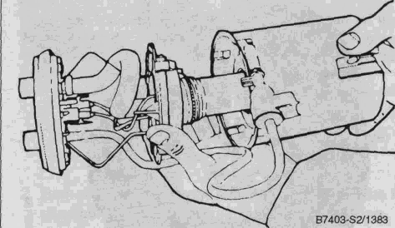

Fig. 23. Threaded collar being tightened using Saab special tool no 83 94 462 on 1990 and later models
Fig. 25. Reservoir and filter unit being separated from pump top section

NOTE
During 1990 production, the supply line check valve was moved from the supply-line socket in the pump to the end of the supply line itself Make sure you identify each fuel line correctly before connecting it
4. Fit a new 0-nng to the ejector pump and reinstall it into the reservoir, turning it 90° counter-clockwise to lock it to the dog on the reservoir.
NOTE
Check that the ejector pump is clean If necessary blow through using compressed air to remove any foreign matenal

To replace fuel pump screen (models with rotor-type pump only)
1. Carefully ease back the lugs that secure the ejector pump, turn the ejector 90° (1/4 turn) clockwise and remove it from the reservoir. See Fig. 24.
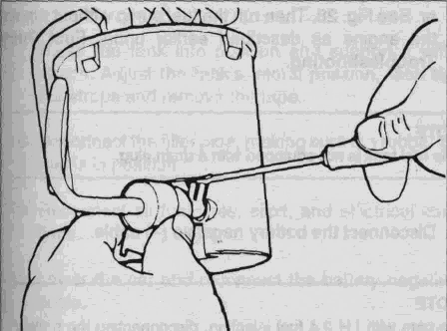
Fig. 24. Ejector pump retaining lugs being eased back Turn ejector 1/4 turn and remove from reservoir assembly
2 Separate the reservoir and filter unit from the top section. See Fig. 25.
3 Install the new reservoir and filter assembly to the pump upper part using a new 0-nng.
Replacing Fuel Pump Check Valve
A one-way check valve is used at the fuel pump supply line to hold fuel pressure in the system after the pump shuts off. A faulty valve can cause longer engine cranking on restart because of the loss of fuel system rest pressure. The check valve is tested as part of a fuel system pressure test as described 240 Fuel Injection
WARNING
• Fuel under pressure will be expelled Wipe up any spilled fuel immediately Wrap fuel lines with a clean rag before removing them Do not smoke or create sparks Have an approved fire extinguisher handy
• Always remove the battery negative (-) cable before doing any work on any fuel system component
To replace the check valve on models with roller-type pump, remove the banjo fitting while holding the pump steady. Then carefully remove the check valve from the pump. Install the new check valve and the banjo fitting, using new sealing washers. See Fig. 26.
CAUTION
Do not grip the check valve too tightly, as it may become damaged

234-14 Fuel Pumo and Fuel Tank

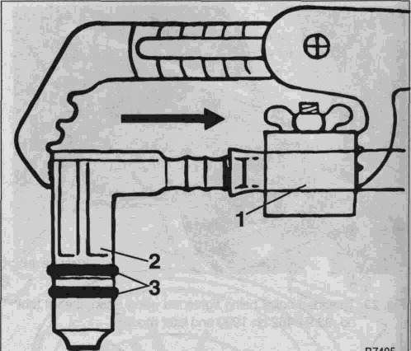
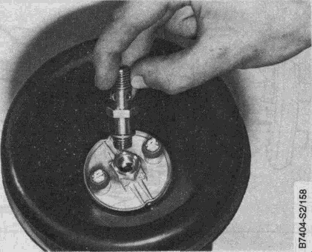
Fig. 26. Fuel pump check valve shown removed from roller-type fuel pump.

On models with the rotor-type pump, two types of check valves were used on the cars covered by this manual. On 1989 models, the return line check valve was part of the fuel pump. On 1990 and later models, the check valve was integrated into the supply line fitting (elbow). If a 1989 pump is being replaced with the newer superseded pump or if the new style check valve is faulty, installation of a newcheck valve will require the use of a special tool.
To install the check valve in the supply line, first cut the old fitting from the end of the line as close as possible to the fitting. Using the special tool (Saab tool no. 83 94 546) and a channel-lock pliers, carefully press the new check valve fitting into the fuel supply line. See Fig. 27. Use new 0-rings when reconnecting the fuel supply line to the pump.
NOTE
Do not cut more than 12-14 mm (1/2 in.) of the supply line when removing the fitting/check valve. If more than this is removed, a new fuel-pump-to-fuel-filter fuel line will have to be installed.
Fig. 27. New supply line check valve (2) being installed with Saab special tool (1). Always use new O-nngs (3).
WARNING
Fuel will be expelled when the fuel lines are disconnected. Do not smoke or create sparks. Have an approved fire extinguisher handy.
To remove and install fuel tank
1. Drain the fuel tank using the fuel pump. Run a hose from the pump outlet on the tank into a suitable container. See Fig. 28. Then run the fuel pump without running the engine as described earlier under Fuel Pump Troubleshooting.
NOTE
The fuel tank is not equipped with a drain plug.

FUEL TANK AND LINES
2. Disconnect the battery negative (-) cable.

Fuel Tank
The fuel tank is held in place with two straps. Removal and installation is fairly straightforward as long as the rear of the car can be raised and supported securely. The following information is a general guide to the necessary steps for tank removal and installation.
NOTE
On cars with LH 2.4 fuel injection, disconnecting the battery cable will erase the control unit's adaptive memory. The engine must be driven for about 30 minutes for the adaptive memory to be reset.
3. Working from the luggage compartment, remove the floor covers and disconnect the electrical leads from the pump and fuel gauge sender.
4. Raise the rear of the car and support it securely.

Fuel Pump and Fuel Tank 234-15

NOTE
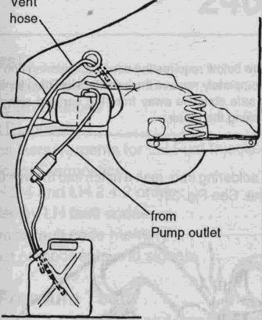
There are different fuel sender gaskets depending on the sender installed. For the most correct replacement, bnng the old gasket to an authorized Saab dealer to match up with the replacement gasket.
1. Disconnect the battery negative (-) cable. Cover the battery terminal.
2. Remove the cover from above the sender in the luggage compartment. Disconnect the sender wiring.
3. Remove the sender's threaded retaining ring.
NOTE
A Saab special tool (tool no. 83 93 365) is available to remove and install the threaded retaining ring. See Fig. 29.

Fig. 28. Setup used to drain fuel tank. A vent hose should be used to prevent emission of hydrocarbons.
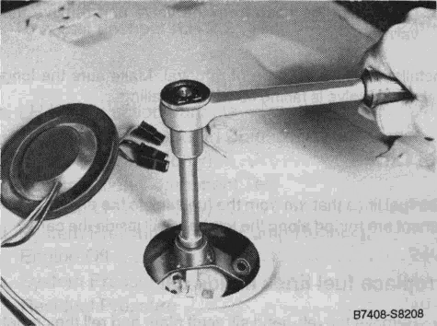
Fig. 29. Fuel gauge sender retaining ring being removed using socket wrench and Saab special tool no. 83 93 365. (Saab Part No. 83 93 365).
5. Disconnect the filler pipe, breather lines, and fuel return line from the tank. Undo the fuel line clips.
6. Remove the strap nuts and lower the tank.
NOTE
Before installing the tank, check that the rubber seal around the fuel sender opening is positioned correctly and undamaged. Cover the tank openings with tape.
7. Raise the tank into position and support it with the straps. Adjust the tank's lateral position, then tighten the straps and remove the tape.
8. Reconnect the filler pipe, making sure the rubber grom-met is in position.
9. Reconnect all fuel lines, clips, and electrical connections.
10. Lower the car and reconnect the battery negative (-) cable.
4. Withdraw the sender and let it drain. Remove the old seal and discard.
5. Fit a new sender seal, insert the sender into the tank, and tighten the retaining ring. Reconnect the wiring and fit the cover.

WARNING
To remove and install fuel gauge sender unit
Fuel will be exposed. Do not smoke or create sparks. Have an approved fire extinguisher handy.
NOTE
New senders are shipped with a retaining wire at the bottom to prevent float damage. Remove the wire before installing the sender, or else the gauge will only read EMPTY.

To replace fuel tank rollover valve
1. Working in the luggage compartment, remove the trim from the right-hand side.

234-16 Fuel Pump and Fuel Tank

2. Remove the rollover valve mounting screws and pull the valve into the luggage compartment. See Fig. 30.
To replace banjo fitting on fuel line

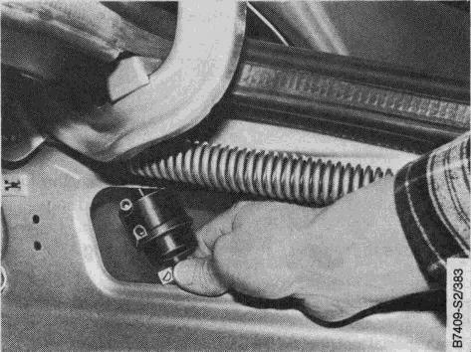
Fig. 31. Soldering iron being used to melt notch in fuel line.
2. Pull the fitting out of the fuel line. Cut the fuel line back just enough to remove the melted notch made earlier.
3. Using a section of thick rubber hose, slice it open and place it over the fuel line. Place the fuel line in a vice. Allow the end of the line to overhang the vise jaws slightly. See Fig. 32.
Fig. 30. Rollover valve in luggage compartment being removed.
3. Disconnect the hose from the valve and remove the valve.
Installation is the reverse of removal. Make sure the long outlet on the valve is facing up when installing.
Fuel Lines
The fuel lines that run from the fuel tanktothe engine compartment are routed along the left-hand sill inside the car.
To replace fuel lines inside car
1. Remove the left-hand sill scuff plate and roll the carpet back.
2. Peel back the tape holding the fuel lines to the body.
3. Carefully remove the insulation felt from the bulkhead.
4. Disconnect the fuel return and supply lines in the engine compartment and pull the lines through the bulkhead grommets and into the passenger compartment.
5. Release the lines from the retaining clips at the fuel tank and remove the lines from the car.
Installation is the reverse of removal. Clean the fuel lines using low pressure compressed air. Tape the open ends before reinstalling them. Always replace fuel fitting sealing washers and any crimp-type hose clamps.
WARNING
The procedure below requires the use of a soldering iron with a knife tip. Completely remove the hose and its fitting from the car. Move a safe distance away from the car and any open fuel when making the repair.
1. Using a soldering iron, melt a notch into the into the end of the line. See Fig. 31.
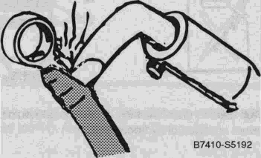
NOTE
As a better alternative to the split rubber hose, use Saab special tool no. 83 94 546 and a channel-lock pliers to install the fitting to the fuel line. See Fig. 27 shown earlier.
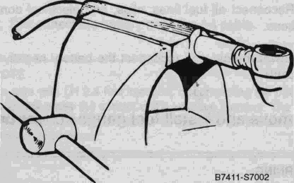

Fig. 32. Fuel line (protected with rubber hose) installed in vice.
4. Tap the fitting into the fuel line until it is fully seated.

